**Name: Ayodeji Abdulfatai Oyinloye**

**Course: Machine Learning with Python**

**Exercise 1.1: History and Tools of Machine Learning**

**Task 1.1: How Companies are Deploying Machine Learning**

**Date: 09.04.2025**

Case Study: [How Companies Are Using Machine Learning](https://www.linkedin.com/pulse/case-study-artificial-intelligence-machine-learning-deepak-sharma)

Question: how is machine learning used in this environment and what does it achieve which human beings cannot (or would be too time intensive)?

**Answer**

**Problem Definition**

Machine learning is the aspect of artificial intelligence involved with feeding computers with input (data), a process called *training*, with the ultimate aim of using it to help solve specific challenges, without preprogramming it outrightly for this. The specific problems being solved in industries range generally from needs to achieve improved revenues/market shares via enhanced customer service on current offers or through innovations, to automation for improved efficiency and avoidance of human error, to need for managing limited staffing capacities without reduction in quality delivery, to quests for technological innovations beyond current practices, etc.

**Background and Hypothesis**

Generally, the approach is to deploy AI to mine big data, extracting useful and actionable part thereof which can then be used to define models (specific suitable data and algorithms combinations) tailored to desired applications. For instance, in the case of service or marketing companies, AI is used to understand what customers are reading/buying – what kind of data is being consumed a lot - to locate users’ interest. Companies then present more of this relevant information as data to train computer with via machine learning, ultimately using this to predict what future consumption would be. This guide is then used to plan future offers to users. The cases of security border post screening, healthcare staffing and self-captained ships discussed in the case study also follow the broad pattern of harnessing relevant big data in those respective environments.

In these environments, given the need to avoid human error that may arise from demanding and stressful volume of work, the perennial changing staffing capacity versus volume of patients served and the need to keep up quality service delivery or the need for high volume real-time decision making, it is clear that efficiency, accuracy and fast turn around time are the advantages of deploying machine learning as against deploying humans directly to complete these tasks.

The state-of-the-knowledge modelling types and broad divisions available are depicted in figure 1 below.

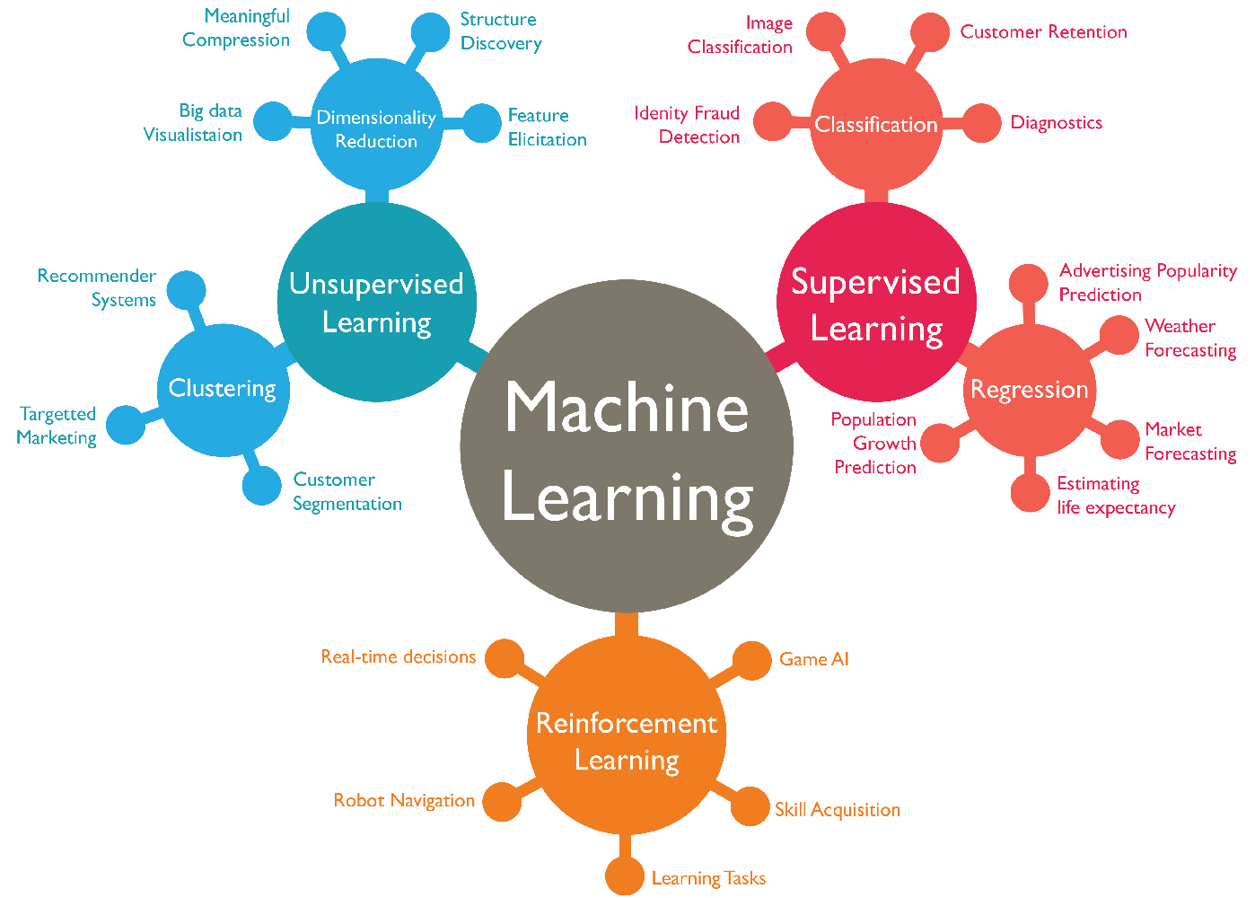

**Figure 1:** the three broad divisions and four subdivisions of machine learning modelling types and respective applications (source: [Link](https://www.linkedin.com/pulse/case-study-artificial-intelligence-machine-learning-deepak-sharma/))

**Solution Provided**

Isolating the healthcare staffing need case, for instance, the appropriate machine learning model helped to achieve exact prediction of staff number required for a given time period. This is an innovative solution that ensured keeping up quality service delivery that would be at risk when more patients than optimal are visiting and the inadequate number of staff is stressed. Additionally, it removed waste that would arise if a greater number of staff were available than required.